**Linear Regression**

We need to find the relationship in a linear equation form: **Y = b0 + b1X**

To do so, we do the following:

* We find the mean for X values, and for Y values.
* Then we find the difference between each X value and the mean, and we do the same for Y values.
* We multiply the sum of both values in the previous point => This is the numerator
* We square the sum of X values - X mean => This is the denominator

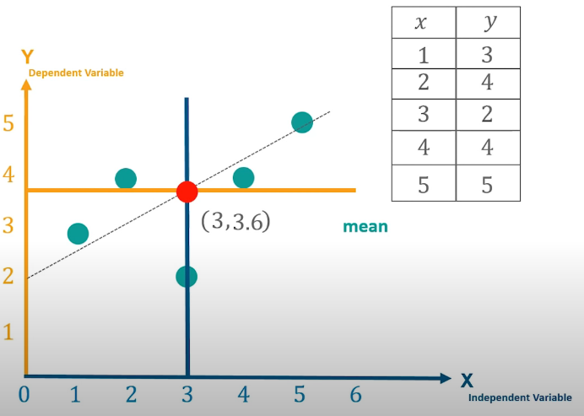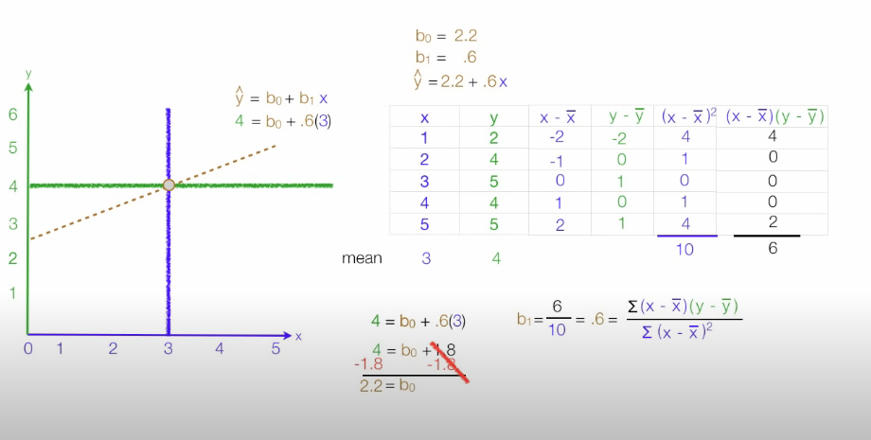

**R-squared value:** (coefficient of determination or coefficient of multiple determination)

A statistical measure of how close the data are to the fitted regression line

